6.5 Stock Movement

    - Stock Movement

      - OEVII – Transfer-Out(Outside Dist)

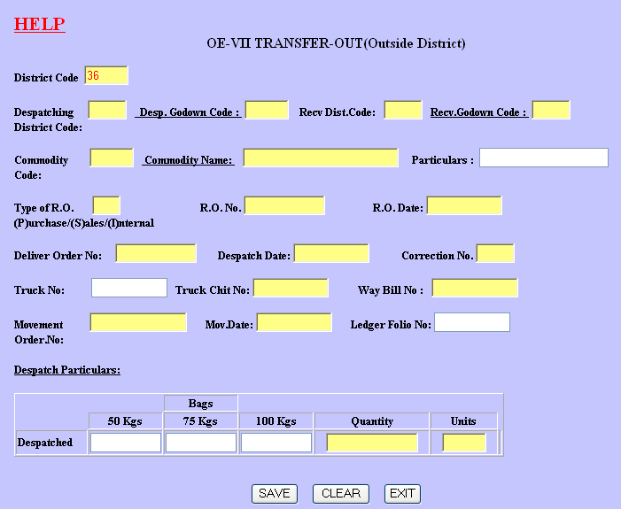

Guidelines:

- Once the stock is dispatched, details have to be entered in this form.
- In case of movement other than purchases/sales, a R.O. MUST be written and entered.
- In case of movement related to purchases/sales, R.O. No./Date should match with R.O.No./Date of Purchase/Sales Day Book.
- Correction no. is 0 in case of first entry. If any corrections are to be made against already entered R.O no., do the following:
1) First enter a canceling entry with same R.O no. and date. Enter the correction no. as 1. Enter bags and quantity as negative values. 2) Make one more entry with same R.O no. and date. Enter the correction No. as 2. Now, make all the correct entries in relevant columns.
3) In case one more correction is to be made, repeat the steps 1 and 2, always incrementing the Correction No. column.
- MLS Code is 99 if not applicable
- Party Code is 99 for other parties. In such case, party name can be changed.
- In case of single R.O and multiple truck chits/commodities, enter each of such entries as separate vouchers.

Sample Vouchers:

      - OEVII – Transfer-Out(Within Dist)

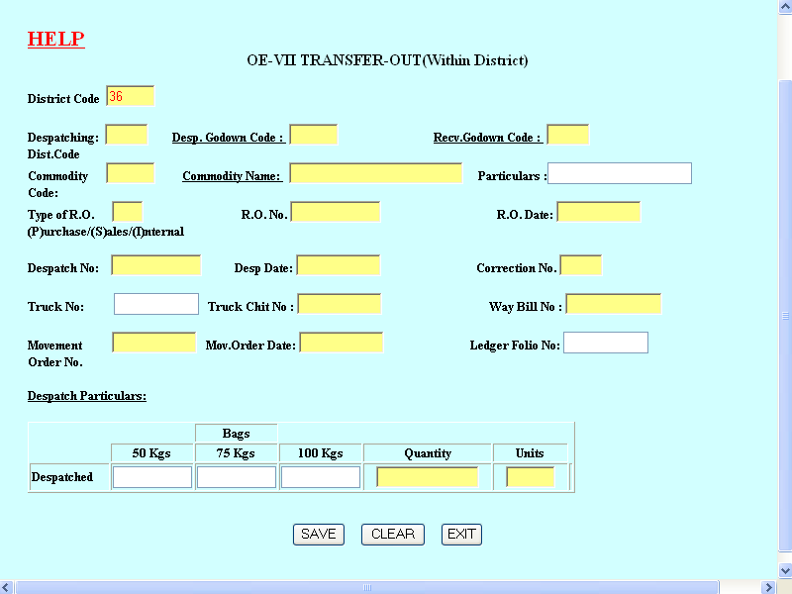

Please refer Topic 6.5.1.1 above for guidelines/help.

      - OEVI – Transfer-In

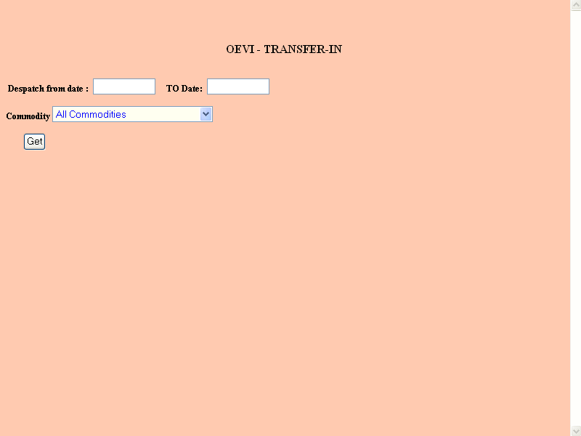

First enter the dispatch period within which some stock is supposed to arrive and select either ‘All commodities’ or chose any commodity. Click ‘Get’ button. If there are dispatches are present for your district, details (sometimes, more than one) are displayed in the following format.

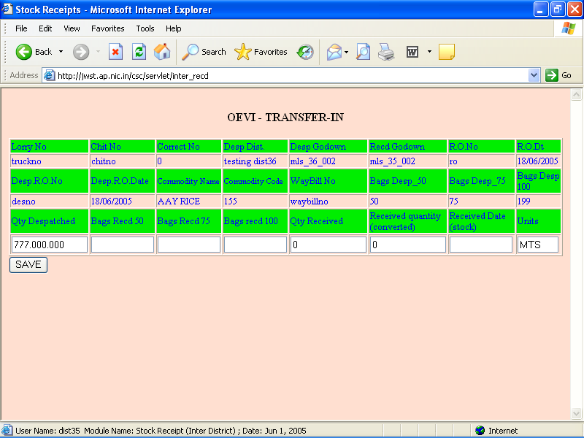

Enter the received bags, quantity and date of receipt. Click ‘Save’ button.

      - Stock Movement

Andhra Pradesh State Civil Supplies Corporation Ltd.
Stock Movement Register for March,2005
District:03 VISHAKAPATNAM
DISPATCHING DIST/GODOWN | COMMODITY NAME | RECEIVING DIST/GODOWN | MOVMT ORDER NO  DATE | PARTICULARS | DESP.RO NO  DATE | RO NO  DATE | RO TYPE

DESPATCHED
LORRY NO | TRUCK CHIT NO | WAY BILL NO | 50 KG BAGS | 75 KG BAGS | 100 KG BAGS | UNITS | DESP QTY

RECEIVED
RECEIVED ON | 50 KG BAGS | 75 KG BAGS | 100 KG BAGS | UNITS | RECD QTY | LOSS QTY | GAIN QTY | LEDGER FOLIO NO
Bottom of Form

    - Stock Ledger

      - Entry

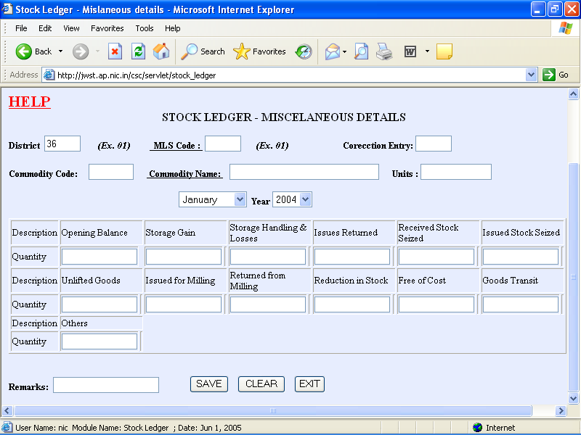

Guidelines:

- At the end of every month, the above details are to be entered.
- Correction is 0 in case of first entry. If any corrections are to be made against already entered month/year, do the following:
1) First enter a canceling entry for the same month/year and commodity. Enter the correction no. as 1. Enter quantities as negative values.
2) Make another entry for the same month/year and commodity. Enter the correction No. as 2. Now, make all the correct entries in relevant columns.
3) In case one more correction is to be made, repeat the steps 1 and 2, always incrementing the Correction No. column.
- MLS/PPC Code is 99 if not applicable
- Once the Commodity code is entered, its name, units and rate per unit automatically appear.

      - Stock Ledger Summary

Andhra Pradesh State Civil Supplies Corporation Ltd.
Stock Ledger Summary for March,2005
District : 03 VISHAKAPATNAM
MLS Point : 010 PADERU
Commodity : DAMAGED PADDY GR A MSP Units: MTS
MONTH/YEAR | OPENING BALANCE |  | PURCHASES |  | TRANSFER IN |  |  | STORAGE GAIN | TRANSIT GAIN |  | ISSUES RETURNED |  | RETURNED STOCK
MONTH/YEAR |  |  |  |  | WITHIN DISTRICT | OUTSIDE DISTRICT
1 | 2 |  | 3 |  | 4 | 5 |  | 6 | 7 |  | 8 |  | 9
ISSUED STOCK SEIZED |  | UNLIFTED STOCKS |  | RETURNED FROM MILLING |  |  | OTHERS RECEIPTS |  |  | TOTAL RECEIPTS
10 |  | 11 |  | 12 |  |  | 13 |  |  | 14(3 to 13)

Andhra Pradesh State Civil Supplies Corporation Ltd.
Stock Ledger Summary for March,2005
District : 03 VISHAKAPATNAM
MLS Point : 010 PADERU
Commodity : DAMAGED PADDY GR A MSP Units: MTS
SALES | TRANSFER OUT |  |  | STORAGE AND HANDLING LOSSES |  | TRANSIT LOSS |  | ISSUED FOR MILLING | OTHER ISSUES |  | STOCK REDUCTION
SALES | WITHIN DISTRICT |  | OUTSIDE DISTRICT
15 | 16 |  | 17 | 18 |  | 19 |  | 20 | 21 |  | 22
FREE OF COST ISSUES |  | TOTAL ISSUES |  |  | CLOSING BALANCE |  | REMARKS |  |  | MONTH/YEAR
23 |  | 24(15 to 23) |  |  | 25(2+14-23) |  | 26 |  |  | 1
Bottom of Form
      - Consolidation

Andhra Pradesh State Civil Supplies Corporation Ltd.
Stock Ledger Consolidation for March,2005
District : 03 VISHAKAPATNAM
COMMODITY | UNITS | OPENING BALANCE | TOTAL RECEIPTS | TOTAL ISSUES | CLOSING BALANCE

  - MIS Reports

    - IORs Received for Ack.

Andhra Pradesh State Civil Supplies Corporation Ltd.
IORs sent by other Districts during March,2005 but not acknowledged
District:03 VISHAKAPATNAM
IOR SENT BY | IOR No. | IOR DATE | HEAD OF ACCT. | ACCT.DESCRIPTION | AMOUNT

    - IOGs Received for Ack.

Andhra Pradesh State Civil Supplies Corporation Ltd.
IOGs sent by other Districts during March,2005 but not acknowledged
District:03 VISHAKAPATNAM
IOG SENT BY | IOG No. and DATE | PARTICULARS | Dr.  HEAD | Dr.  HEAD DESC | Dr.  AMOUNT | Cr.  HEAD | Cr.  HEAD DESC | Cr.  AMOUNT

    - IOCPFs Received for Ack.

Andhra Pradesh State Civil Supplies Corporation Ltd.
IOCPFs sent by other Districts during March,2005 but not acknowledged
District:03 VISHAKAPATNAM
IOCPF SENT BY | IOCPF No. and DATE | PARTICULARS | Dr.  HEAD | Dr.  HEAD DESC | Dr.  AMOUNT | Cr.  HEAD | Cr.  HEAD DESC | Cr.  AMOUNT

    - Account Head Balances

Andhra Pradesh State Civil Supplies Corporation Ltd.
Account Head wise Net Balances in General Ledger for March,2005
District : 03 VISHAKAPATNAM
ACCT.HEAD | DESCRIPTION | DR./CR. | AMOUNT
0601 | A. CURRENT LIABILITIES | DR | 2000.00
060101 | LIABLITIES FOR PURCHASES-LEVY RICE | CR | 500.00
060102 | LIABLITIES FOR PURCHASES -PADDY | CR | 500.00

    - Cash Balances

Andhra Pradesh State Civil Supplies Corporation Ltd.
District: VISHAKAPATNAM
DAILY BALANCES

DIST CODE | DATE | OPENING BALANCE | PAYMENTS | RECEIPTS | CLOSING BALANCE

    - View Vouchers

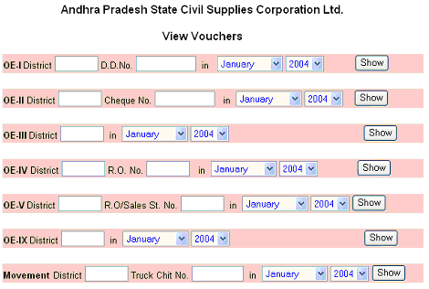

Andhra Pradesh State Civil Supplies Corporation Ltd.
OEI - Receipts Cash Book. Vouchers related to DD No. dd1 during March,2005
District:03 VISHAKAPATNAM
VR.  NO | VR. DATE | DD DATE | PARTY NAME | AMOUNT | Dr.HEAD | Dr.HEAD DESC | Dr.AMOUNT | Cr.HEAD | Cr.HEAD DESC | Cr.AMOUNT
Bottom of Form

Andhra Pradesh State Civil Supplies Corporation Ltd.
OEII - Payments Cash Book. Vouchers related to Cheque No. ch1 during March,2005
District:03 VISHAKAPATNAM
VR.NO | VR. DATE | DD DATE | PARTY NAME | AMOUNT | Dr.HEAD | Dr.HEAD DESC | Dr.AMOUNT | Cr.HEAD | Cr.HEAD DESC | Cr.AMOUNT
Bottom of Form

Andhra Pradesh State Civil Supplies Corporation Ltd.
OEIII - Petty Cash Book for March,2005
District:03 VISHAKAPATNAM
VR.NO | VR. DATE | PARTY CODE | PARTY NAME | PARTICULARS | Cr.HEAD | Cr.HEAD DESC | Cr.AMOUNT | Dr.HEAD | Dr.HEAD DESC | Dr.AMOUNT
Bottom of Form

Andhra Pradesh State Civil Supplies Corporation Ltd.
OEIV - Purchase Day Book. Vouchers related to R.O. No. ro1 during March,2005
District:03 VISHAKAPATNAM
VR.NO | VR. DATE | COMMODITY | SUPPLIER | CORR.NO. | R.O.DATE | M.L.S.POINT | UNITS | QUANTITY | COST

Cr.HEAD | Cr.HEAD DESC | Cr.AMOUNT | Dr.HEAD | Dr.HEAD DESC | Dr.AMOUNT
Bottom of Form

Andhra Pradesh State Civil Supplies Corporation Ltd.
OEV - Sales Day Book. Vouchers related to R.O. No. st1 during March,2005

District:03 VISHAKAPATNAM
CORR.NO. | R.O.DATE | COMMODITY | PARTY | M.L.S.POINT | UNITS | QUANTITY | COST

Dr.HEAD | Dr.HEAD DESC | Dr.AMOUNT | Cr.HEAD | Cr.HEAD DESC | Cr.AMOUNT
Bottom of Form
Andhra Pradesh State Civil Supplies Corporation Ltd.
OEIX - Journal for March,2005
District:03 VISHAKAPATNAM

VR.  NO | VR. DATE | O.B.  VOUCHER | PARTY NAME | PARTICULARS | IOG No. and DATE | IOG RCVD FROM | IOG SENT BY | IOCPF No. and DATE | IOCPF RCVD FROM | Cr.  AMOUNT

Dr.HEAD | Dr.HEAD DESC | Dr.AMOUNT | Cr.HEAD | Cr.HEAD DESC

Bottom of Form

Andhra Pradesh State Civil Supplies Corporation Ltd.
Stock Movement Details related to Truck Chit No. tc1 during March,2005
District:03 VISHAKAPATNAM
CORR.NO. | MOVMT.DATE | RO NO/  DATE | RO TYPE | COMMODITY | UNITS | DESP.DISTRICT/  GODOWN | DESP.QTY

RCVD.DISTRICT/  GODOWN | RECD.QTY | LOSS QTY | GAIN QTY
Bottom of Form

    - Stock Movement Summary

ANDHRA PRADESH STATE CIVIL SUPPLIES CORPORATION LTD.
Purchase R.O Wise Stock Movement Summary For R.Os Issued During March,2005
District:03 VISHAKAPATNAM
R.O.NO. | R.O.DATE | COMMODITY CODE | COMMODITY NAME | UNITS | TOTAL QUANTITY | QUANTITY MOVED | BALANCE QUANTITY
Bottom of Form

ANDHRA PRADESH STATE CIVIL SUPPLIES CORPORATION LTD.
Sales R.O Wise Stock Movement Summary For R.Os Issued During March,2005
District:03 VISHAKAPATNAM
R.O.NO. | R.O.DATE | COMMODITY CODE | COMMODITY NAME | UNITS | TOTAL QUANTITY | QUANTITY MOVED | BALANCE QUANTITY
Bottom of Form

ANDHRA PRADESH STATE CIVIL SUPPLIES CORPORATION LTD.
Internal Stock Movement Summary For Movement Made During March,2005
District:03 VISHAKAPATNAM
TRUCK CHIT NO. | MOVMENT DATE | COMMODITY CODE | COMMODITY NAME | UNITS | TOTAL QUANTITY | QUANTITY MOVED | BALANCE QUANTITY
Bottom of Form

    - Trial Balance

Andhra Pradesh State Civil Supplies Corporation Ltd.
Trial Balance from April,2005 to March,2006
District : 03 VISHAKAPATNAM
ACCT.HEAD | DESCRIPTION | DR. AMOUNT | CR. AMOUNT
7801 | OTHER MISC . INCOME | 0.00 | 1048.34
990701 | CASH SALE CONTROL | 6243025.58 | 0.00
060104076 | EXCESS COLLECTIONS | 0.00 | 94468.12
610101010 | SALES RICE PDS | 0.00 | 4860046.77
610101011 | SALES RICE AAY | 0.00 | 614890.38
610101020 | SALES WHEAT | 0.00 | 19778.00
610101030 | SALES LEVY SUGAR | 0.00 | 471371.89
610201021 | SALES WHEATOM | 0.00 | 181422.08
 | TOTAL | 6252306.63 | 6252306.63
Bottom of Form

The underlined heads of accounts can be further clicked to get the General Ledger details for respective account head.

